

CPSIM PROJECT



**GROUP MEMBERS:**

* Abdul Majeed (1444906)
* Hadiya Nazim (1441535)
* Muhammad Usman (1436443)
* Zaid Malik (1436877)

**A-1 UNIFORMS**

**TABLE OF CONTENT**

…………………………………………………………………………….………………………………………..0

ACKNOWLEDGMENT……………………………………….………………………………………0

CERTIFICATE OF……………………………………………………….………………………………0

COMPLETION………………………………………………………….………………………………….0

PROBLEM STATEMENT………………………………………….……………………………….0

PROPOSED SOLUTION :…………………………………………………………………………0

FUNCIONAL REQUIREMENTS :…………………………………………………………….0

HOME PAGE……………………………………………………………….………………………………0

SCREEN SHOTS………………………………………………………….…………………………….0

REGISTRATION FORM……………………………………………….…………………………...0

DATA BASE…………………………………………………………………….………………………...0

WORK BREAKDOWN CHART……………………………………….……………………….0

CONCLUSION…………………………………………………………………….……………………..0

**ACKNOWLEDGMENT**

I would like to express my very appreciation to **MISS LARAIB** for her valueable and constructive suggestions during the planning and preparation of our project.Her willingness to give her time so generously has been very much appreciated.

I would also like to thankfull the staff and teachers of **APTECH METRO STARGATE** due to this pandemic.

Situation they give the permission to visit their offices to solve my problem

CE

**CERTIFICATE OF COMPLETION**

**CERTIFICATE**

**OF**

**COMPLETION**

**THIS IS TO CERTIFY THAT**

**Abdul Majeed, Hadiya Nazim, Muhammad Usman, Zaid Malik**

HAS COMPLETED TO ALL THE REQUIRED STATEMENTS AT THE PROJECT.

**AUTHORIZED SIGNATURE**

**01-June-2023**

**ISSUANCE DATE**

**PROBLEMS STATEMENTS**

School uniforms are a hotly contested debate, which makes it a controversial topic preferred for school essays. Even though writing a school uniform essay should be easy, students' confessions after being assigned both long and short essays on school uniform show mixed results. Most students who have been given an essay on school uniforms have highlighted it as exciting and tricky.

Well, to write an essay that will score you an excellent grade, you need to understand your perspective, viewpoint, or stand before writing. As yourself, whether you will support school uniforms or you will be against them in your essay.

In most cases, the essay can be argumentative where you argue either for or against, then proceed to state your stand on whether or not you support school uniforms in learning institutions. You can also write an informative essay or a persuasive school uniform essay.

This article covers some aspects to consider when writing such an essay, some suitable topics, and general advice on how to write an outstanding school uniforms essay.

You aim to demystify the school uniforms debate. Therefore, you need to strategize on how to begin the essay. Like other essays, starting with an essay hook would make it interesting to the readers. After the hook, head straight to writing some background information on school uniforms. You can then incorporate a thesis statement that presents your central stance on the paper.

Here is a sample school uniform hook:

**A recent study by North Dakota State University revealed that an average American household spends close to 3.8% of their income on clothing, translating to approximately $2000 annually per household.**

The hook above is essential when you argue from a cost perspective where you say that school uniforms save families from expenditures on buying different clothes for kids, which equalizes the rich and poor households.

In your background, you can try reference instances when school uniforms have stirred public debates. Inform your reader about these debates and highlight the key issues you will handle in your essay.

At the end of the introduction paragraph, state your thesis statement.

With the introduction done, you now need to develop the body paragraphs. As a general rule, always maintain a single idea per paragraph. If you are doing your essay in a five-paragraph essay format, ensure that the body of your essay takes 80% of the total word count while the introduction and the conclusion each take 10%.

Here are some key ideas you can incorporate in the body of your essay:

* Explain the essence of having school uniforms on students, teachers, and learning institutions. Issues such as security and safety, uniformity, and promoting togetherness or unity as benefits. It is easy to spot a student in uniform. School uniforms also enforce some self-respect and self-worth among students. As well, uniforms foster a sense of belonging among students.
* Explore the issue from a cost-saving perspective for the parents. Unlike having different clothes daily, having a few pieces of school uniforms reduces the expenditure per household.
* Connect school uniforms to issues such as creativity, comfort, and affordability. Lack of funds, for instance, can hinder some families from sending their children to school as they have no school uniforms.
* You can also present the pros and cons of school uniforms
* Connect the school uniforms to identity formation
* School uniforms equalize students, which boosts their self-confidence
* School uniform makes students not be imaginative
* In the end, present recommendations that can solve the school uniform quagmire in schools

Like any other essay, ensure that your essay about school uniforms is engaging. Take a multi-stakeholder approach if you are recommending a policy.

If you have real-life examples of how school uniforms are beneficial, present them to support your body paragraphs. As you strive to present your viewpoints, ensure that each paragraph transitions to the next paragraph.

If possible, benchmark your arguments on schools that have successfully implemented school uniforms.

**Hardware :**

* A minimum computer system that will help you access all the tools in the courses is a Pentium 166 or better
* 64 Megabytes of RAM or better

**Software *[Either or Combination as per Course/Sem]:***

* Notepad/HTML editor/CoffeeCup
* Angular / Angular JS / React / BootStrap
* Dreamweaver / Figma
* MS IE / Chrome / FireFox / Netscape /MS Edge

**Hardware/ Software Requirements**

**SCREEN SHOTS**

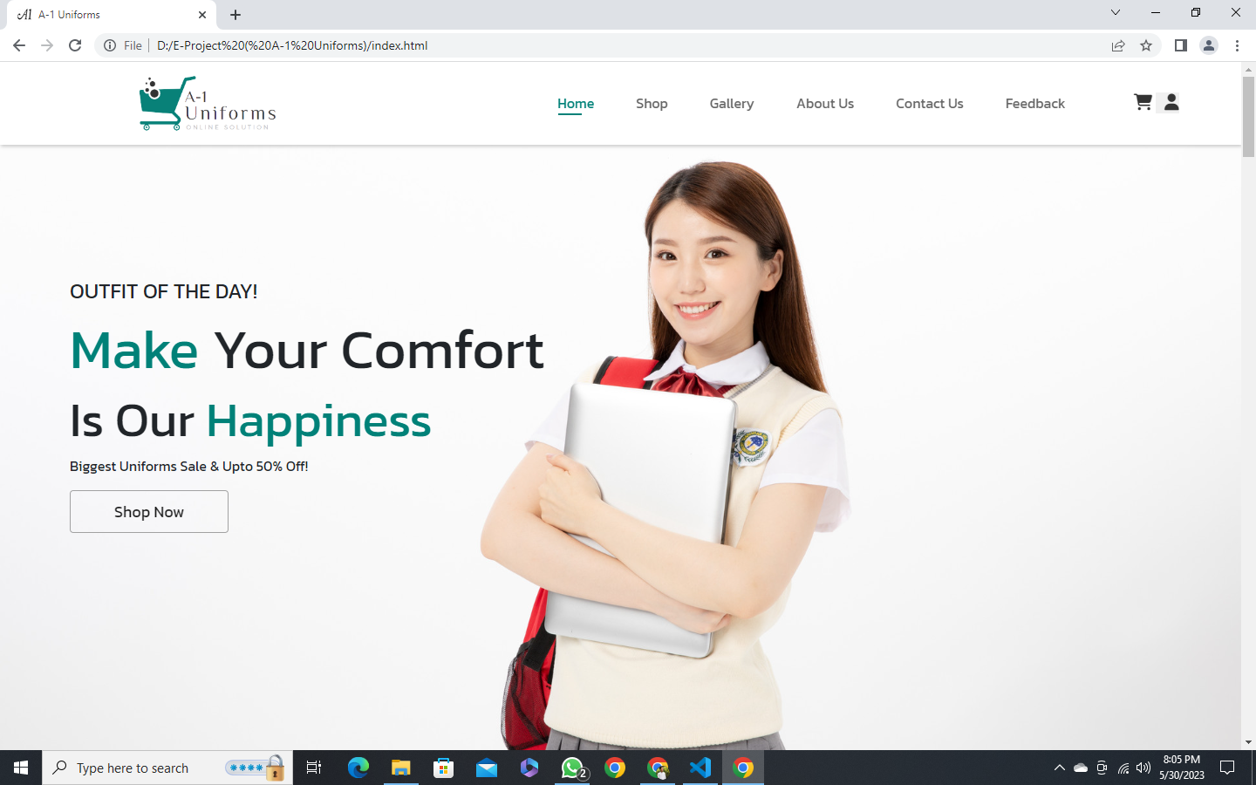HOME PAGE:

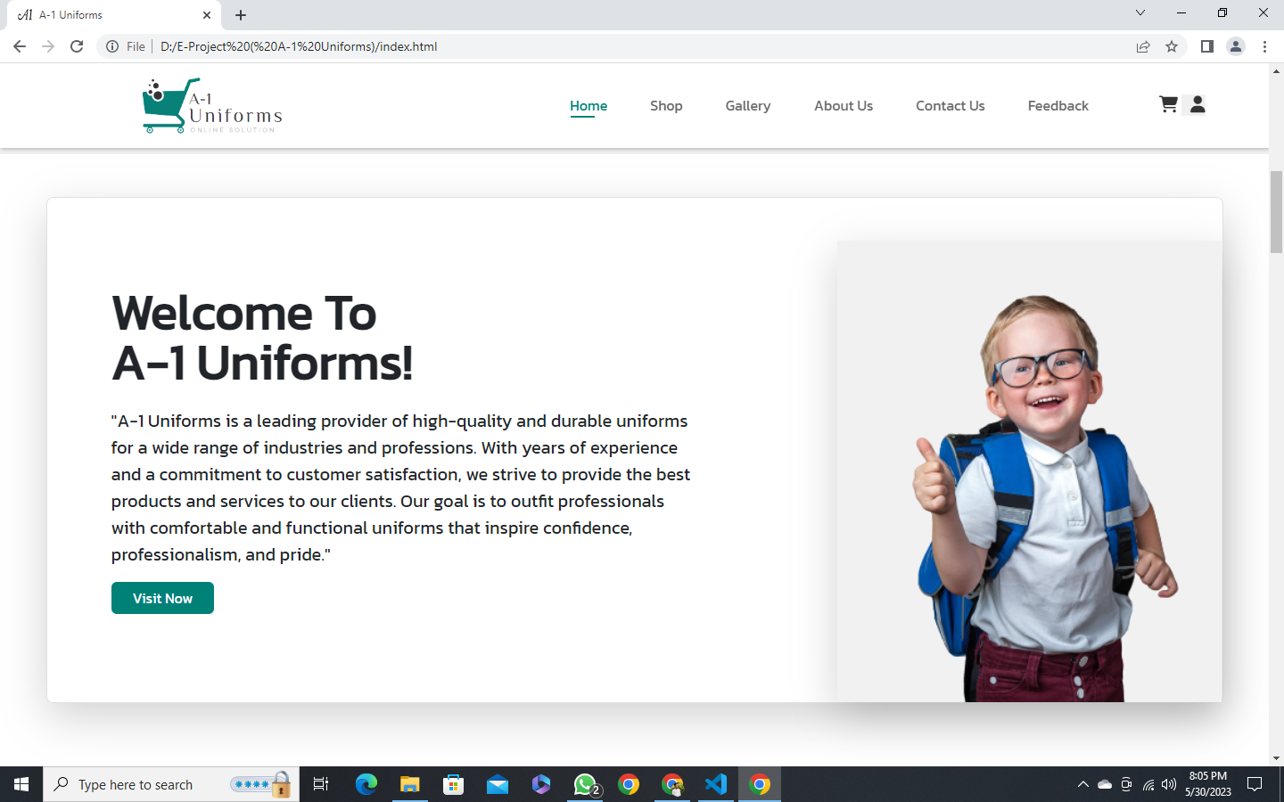

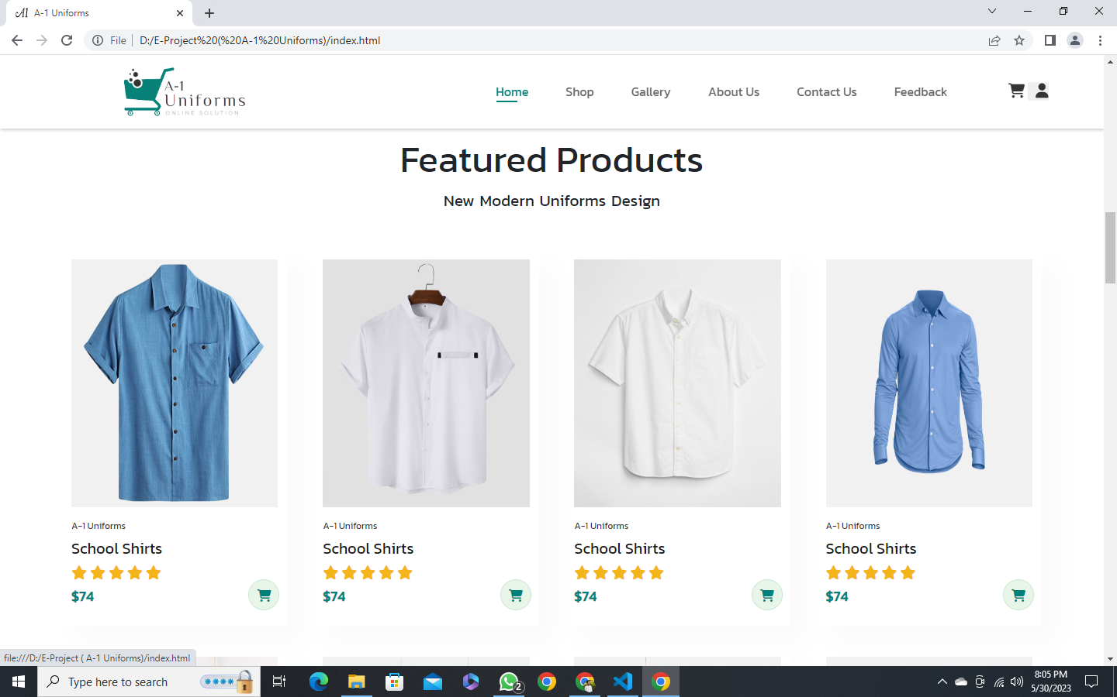

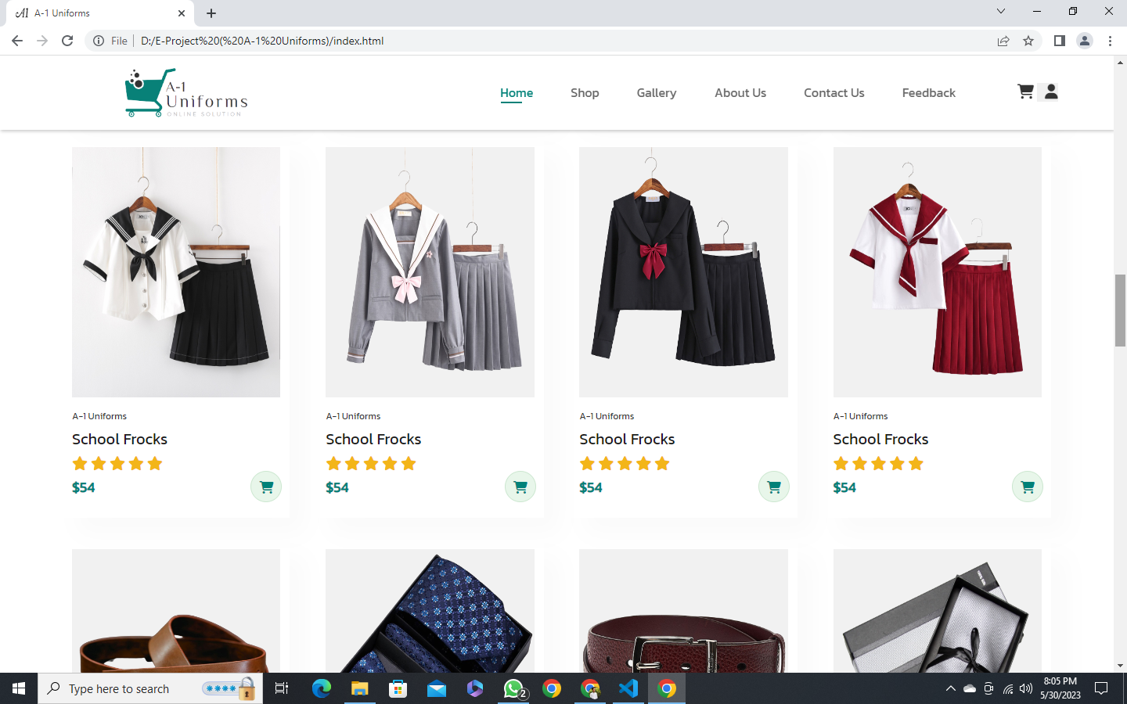

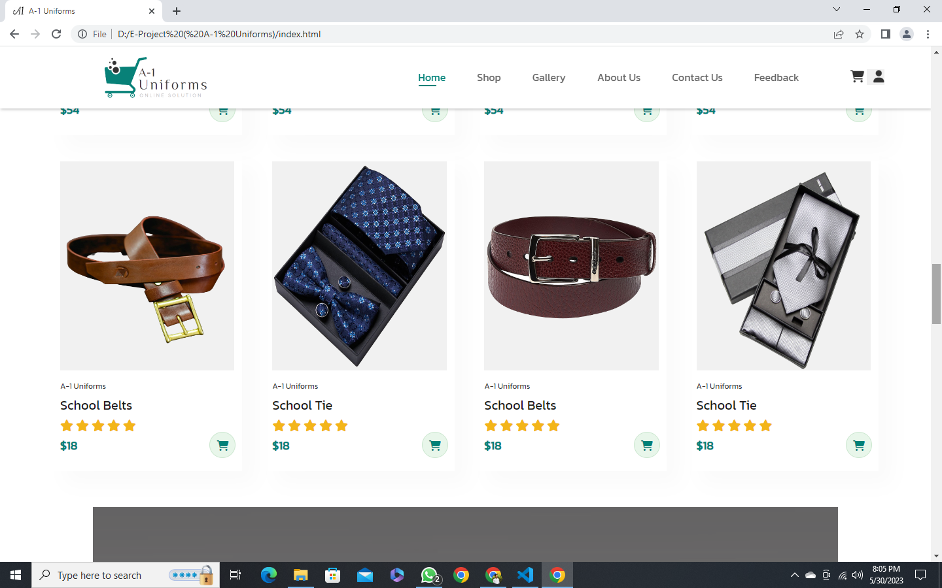

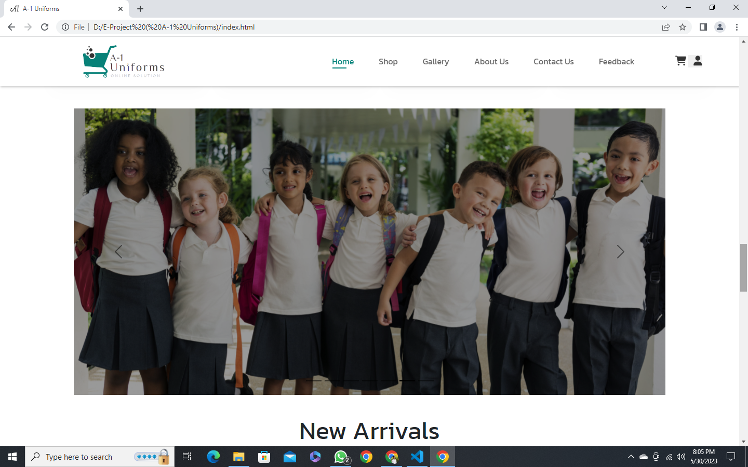

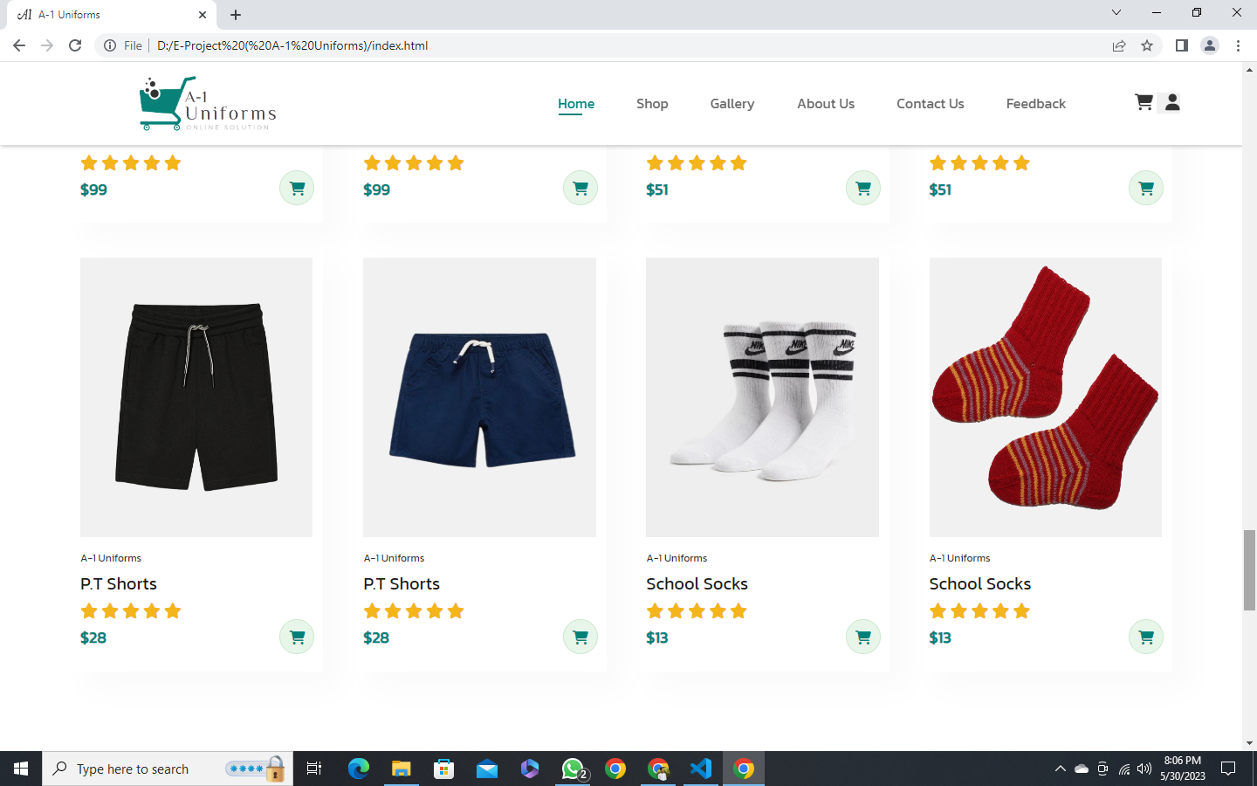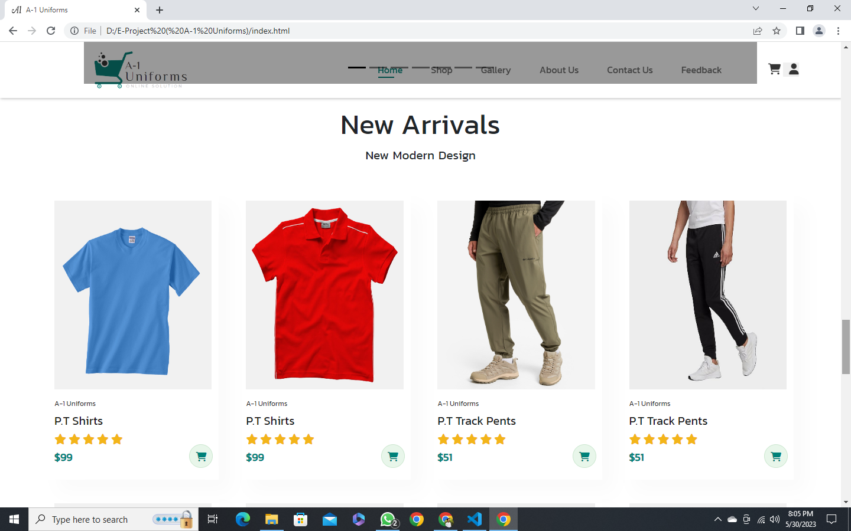

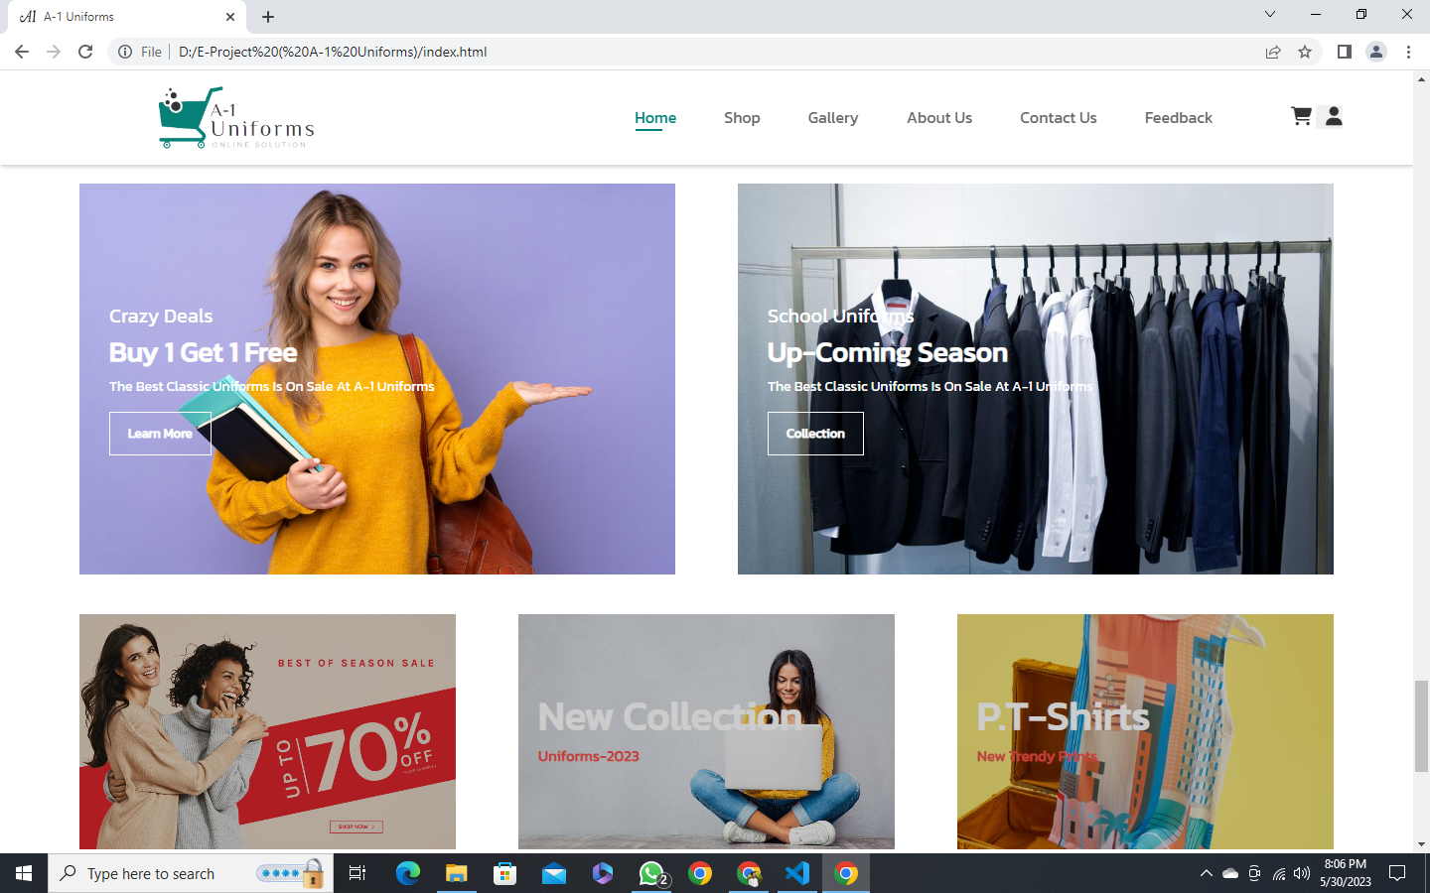

Our Shop:

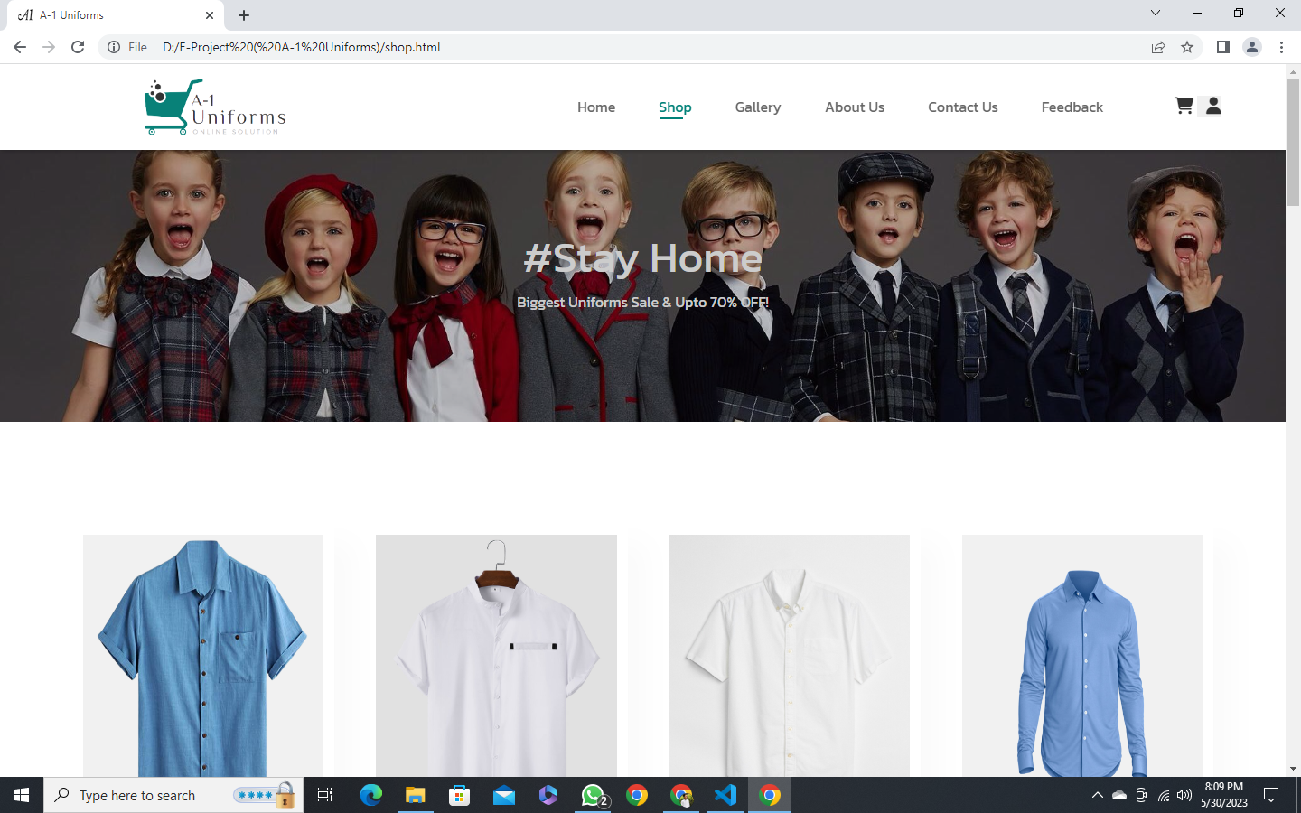

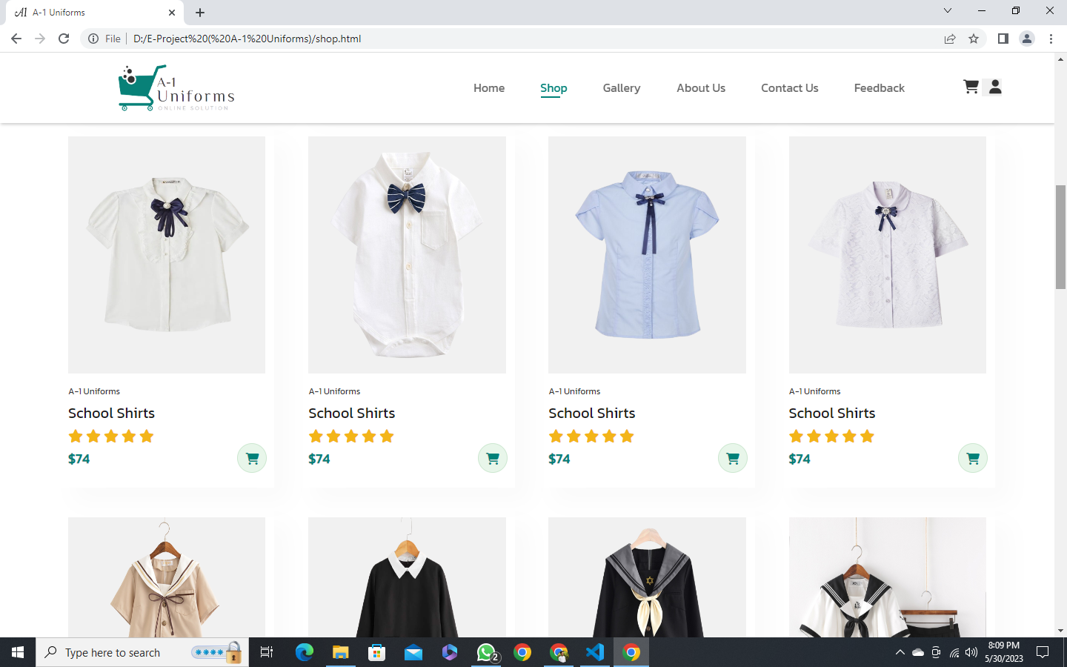

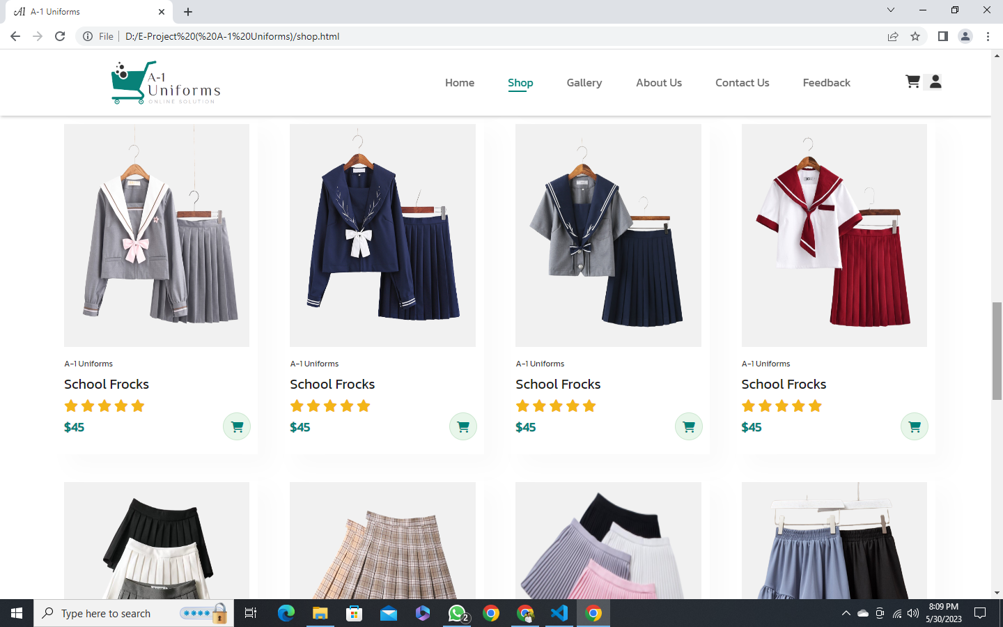

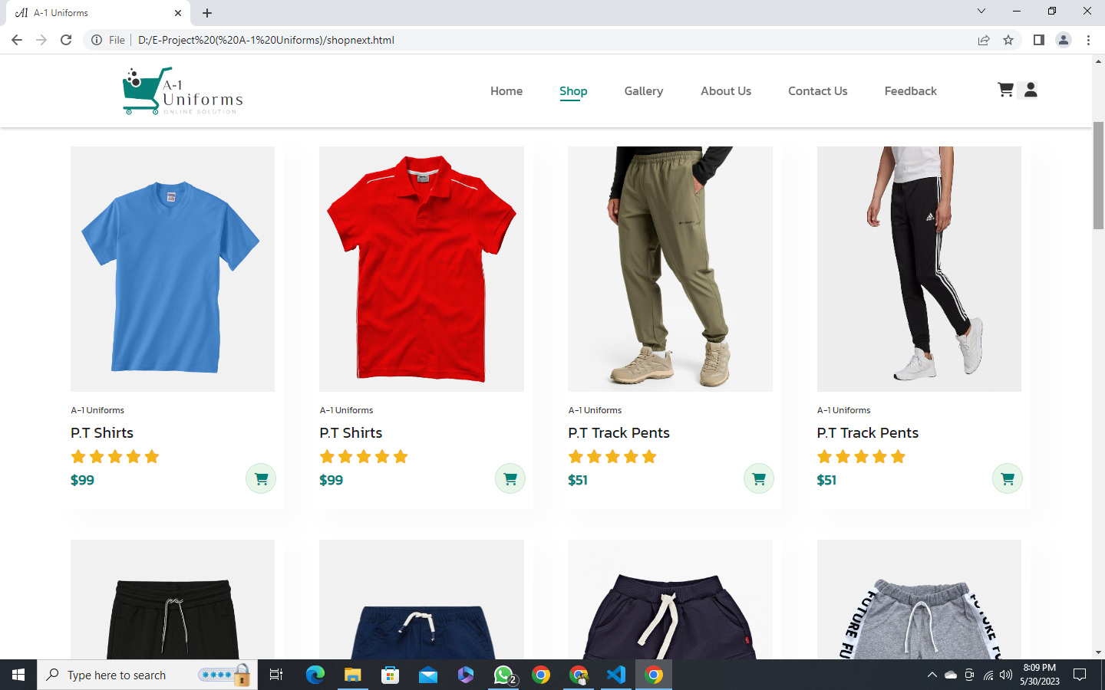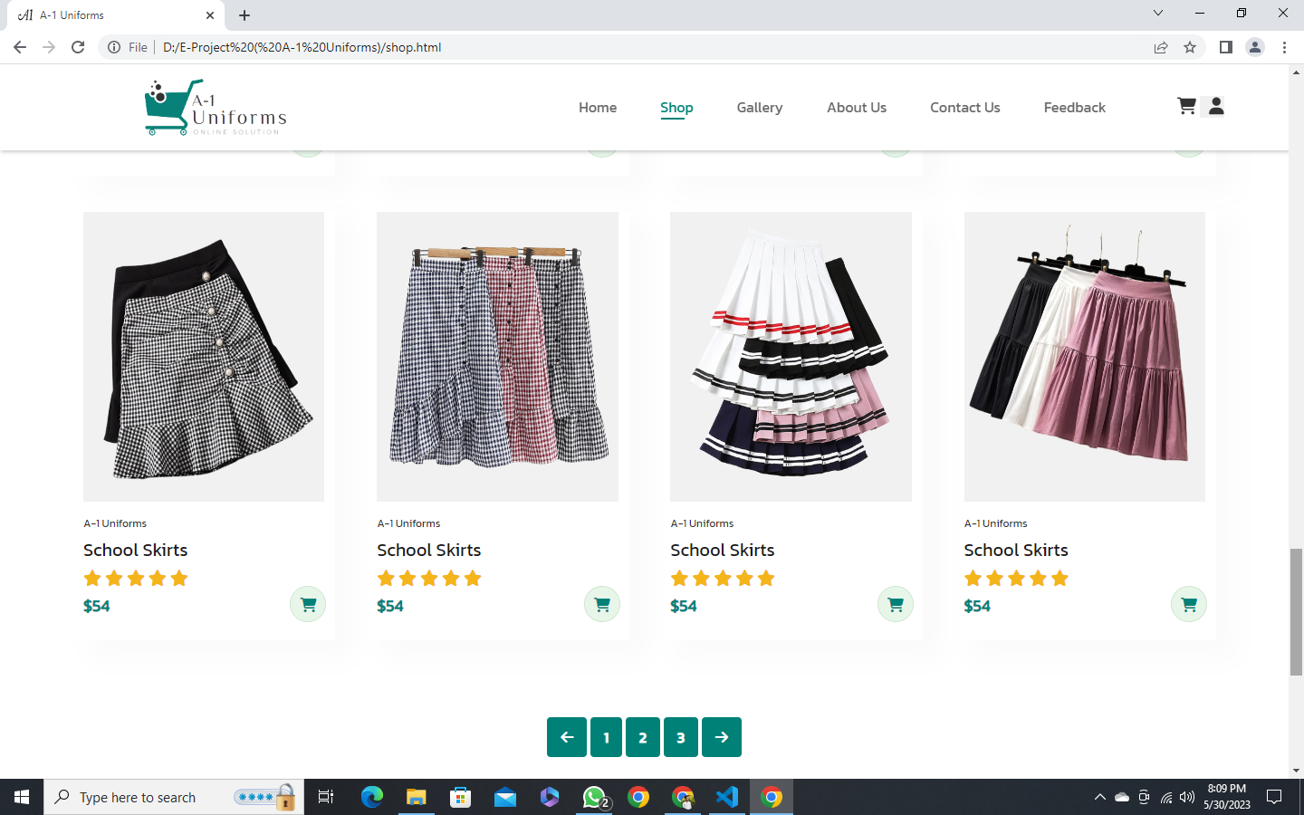

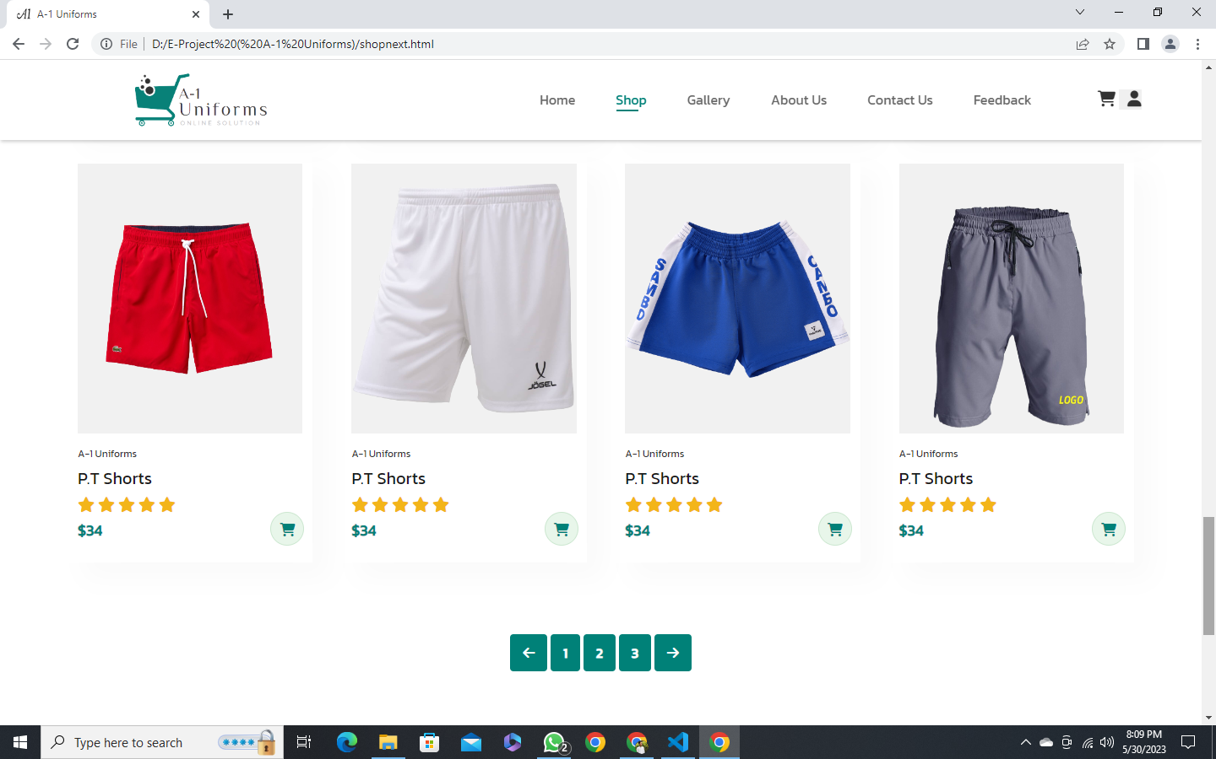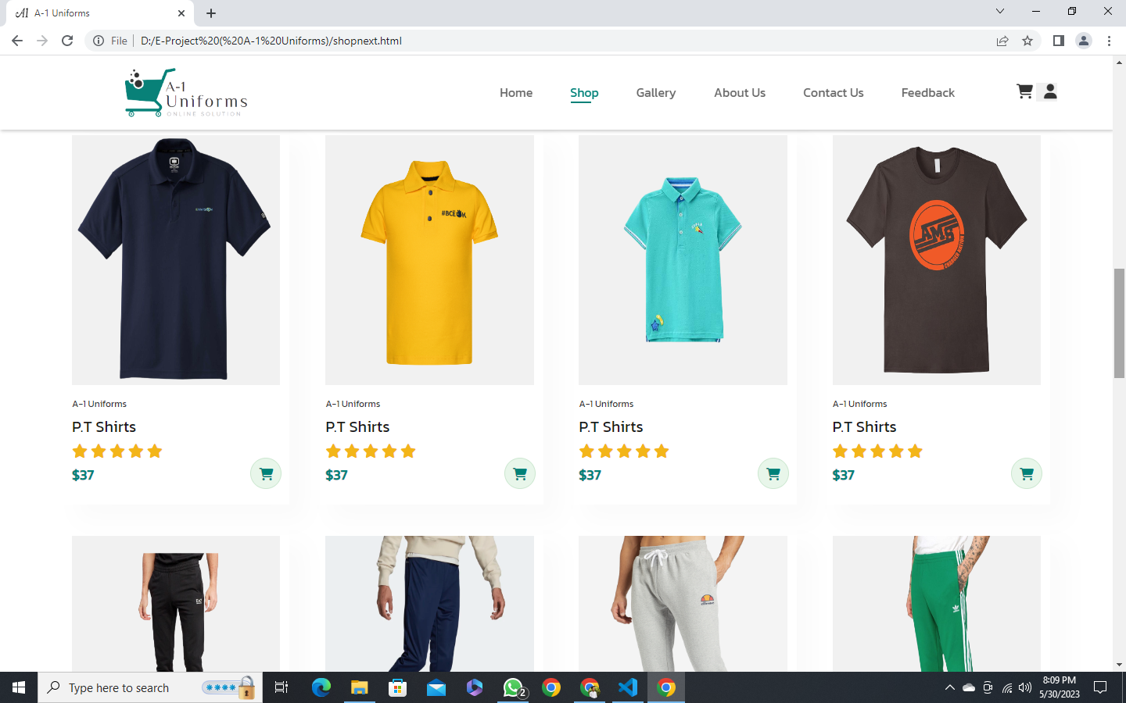

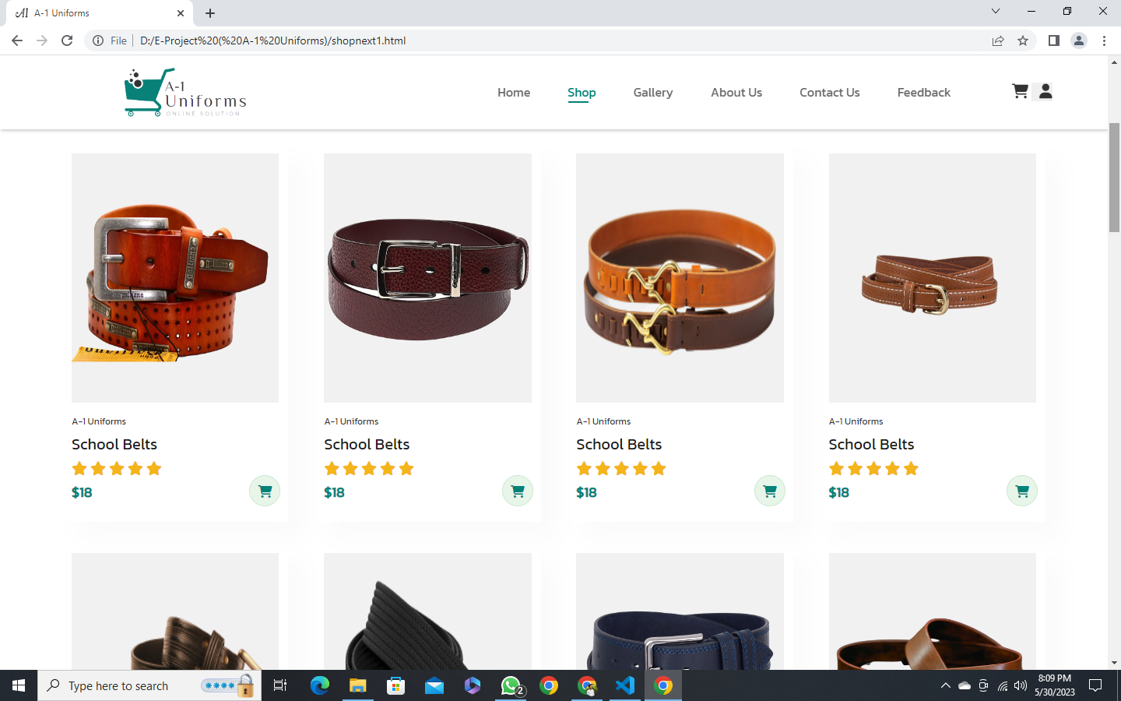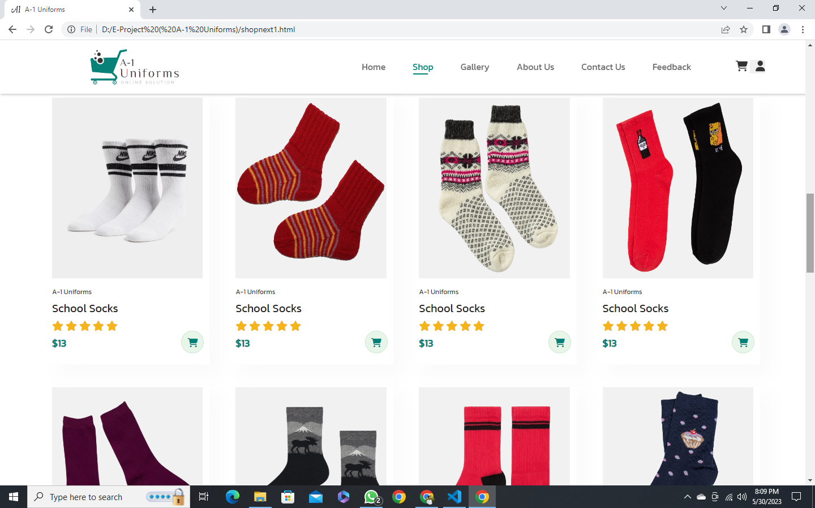

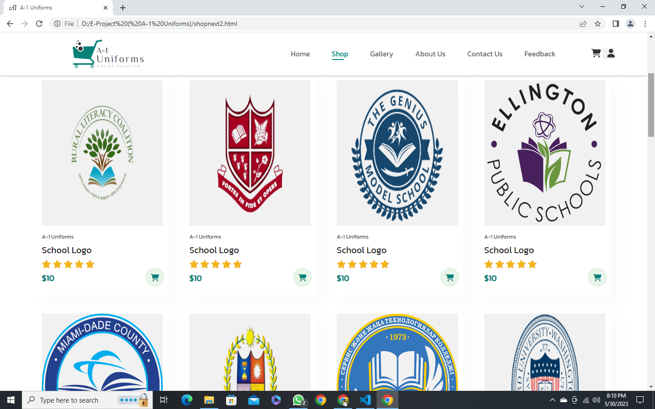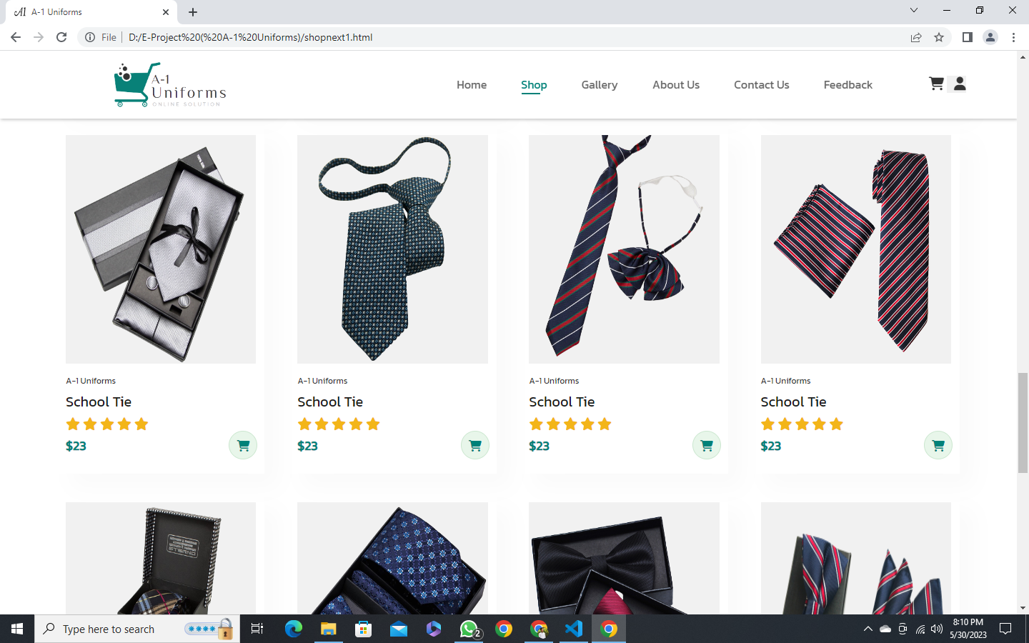

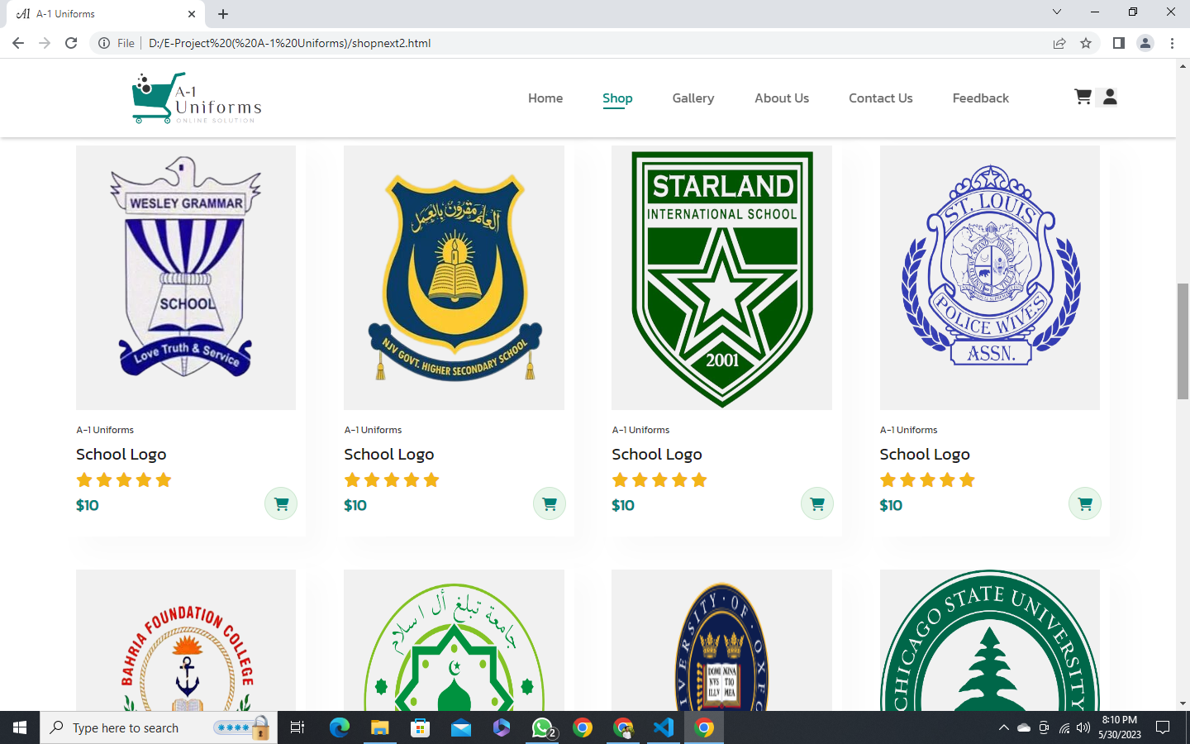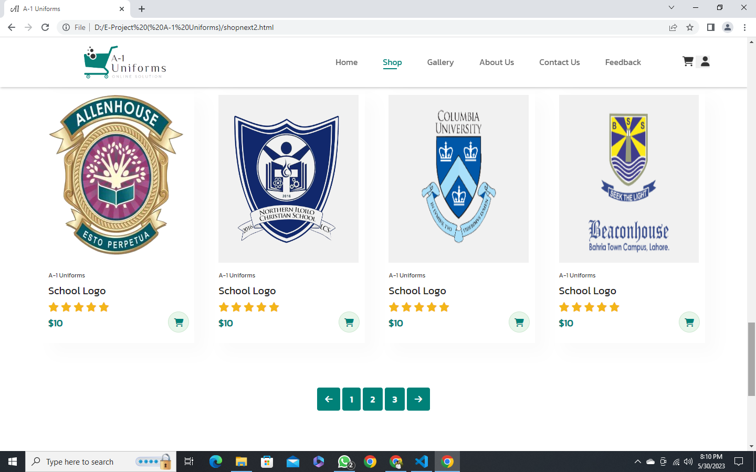

Our Gallery:

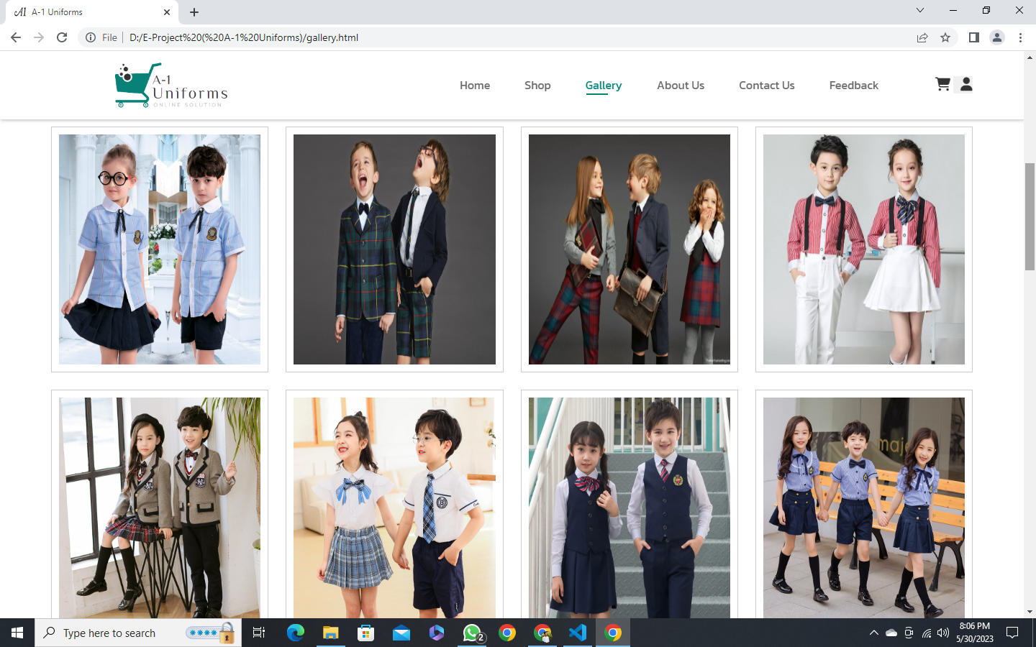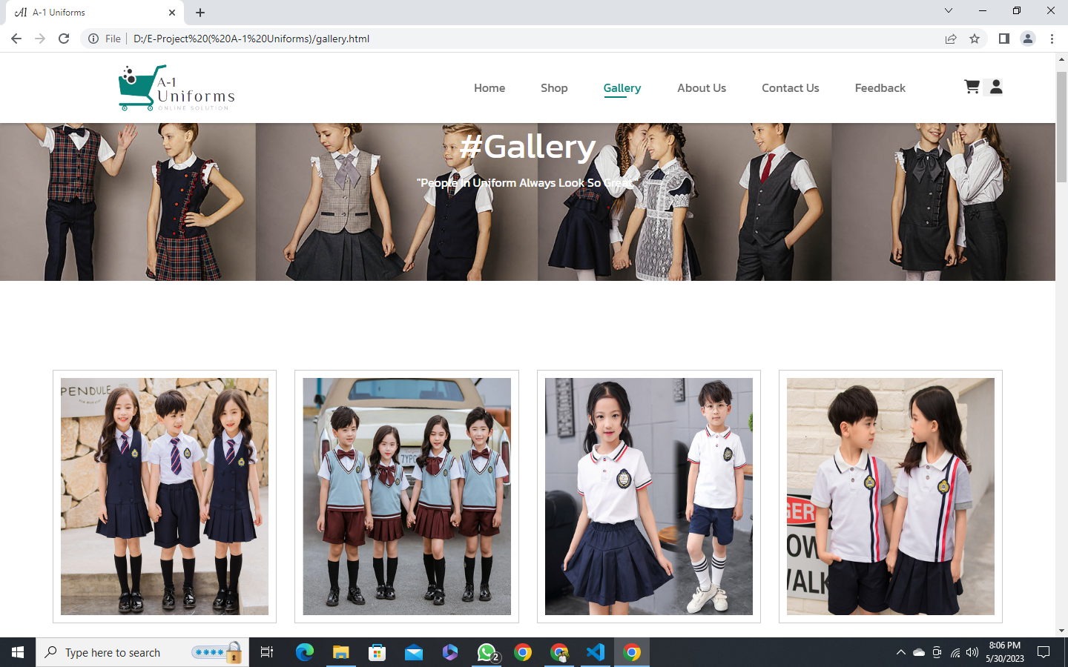

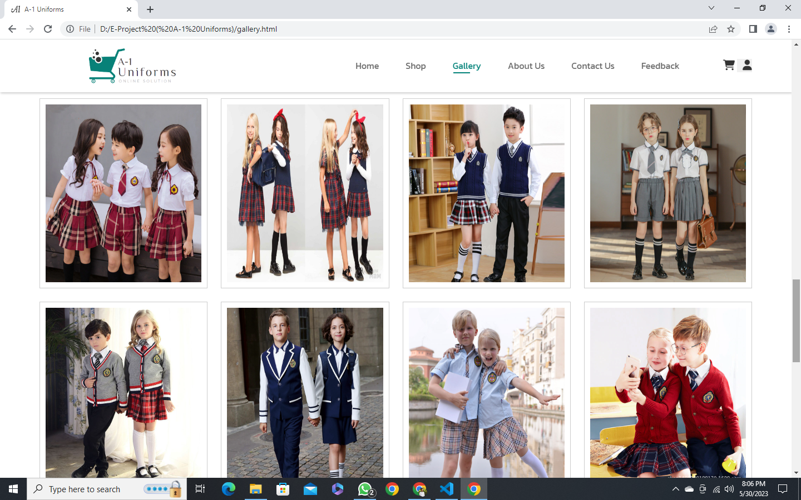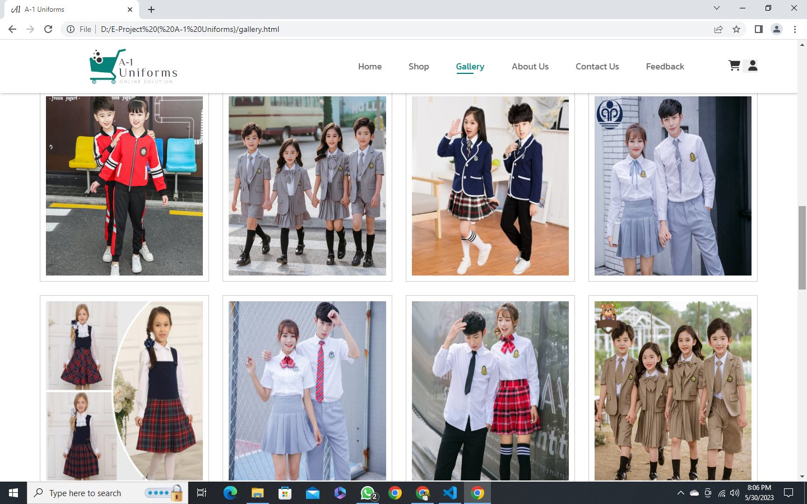

About US:

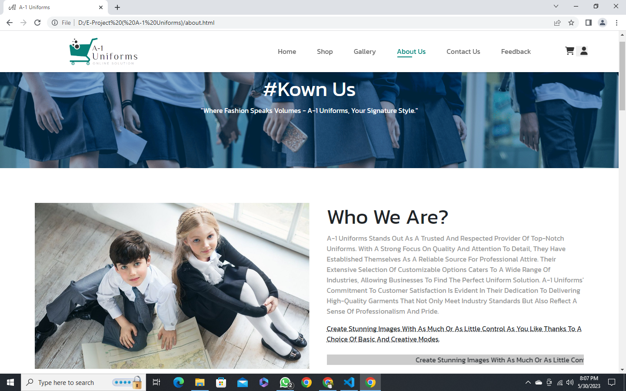

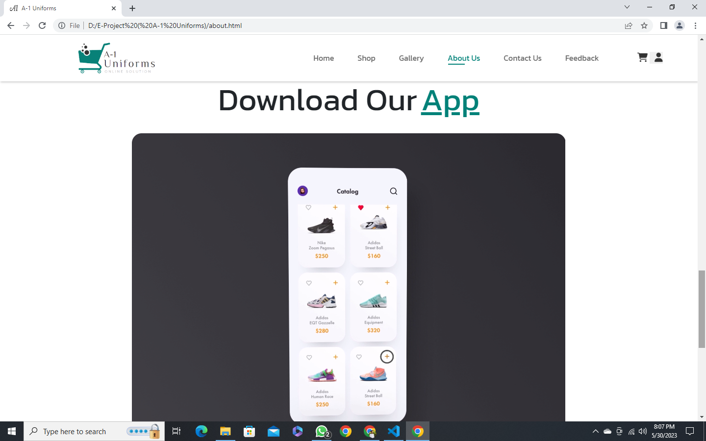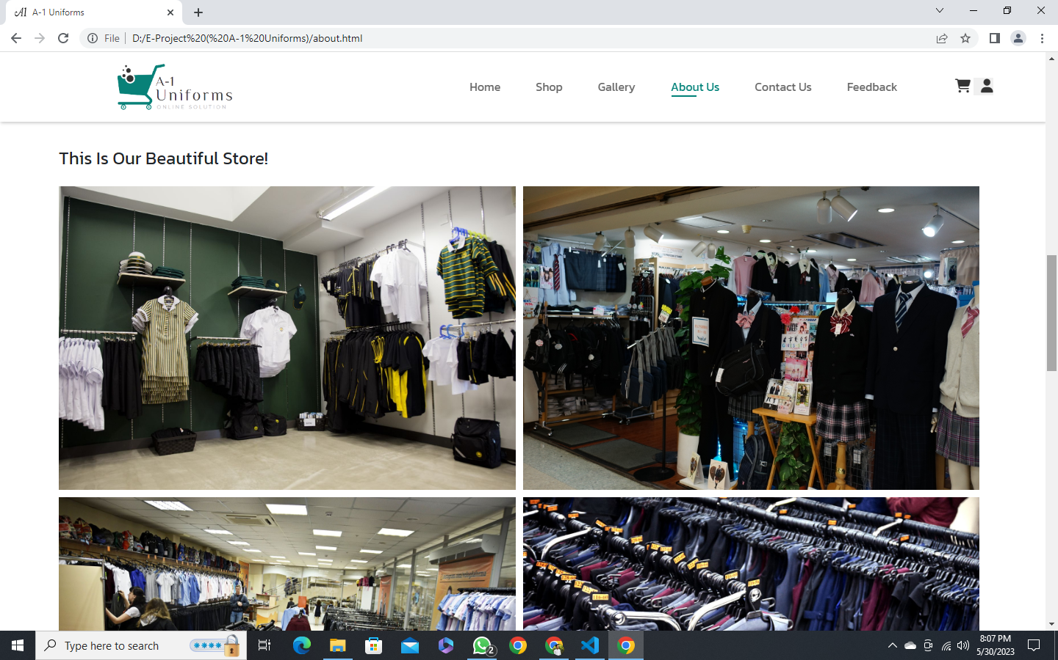

Contact US:

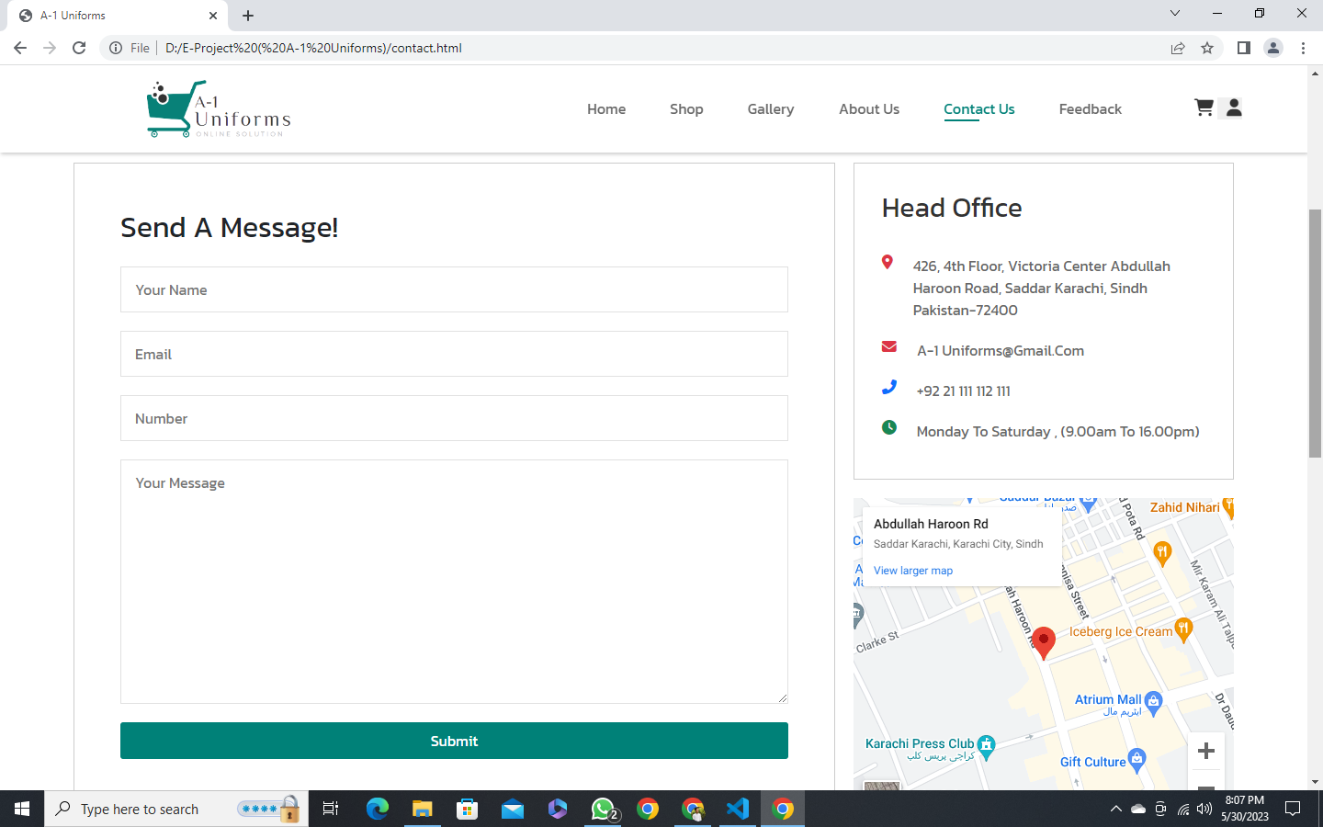

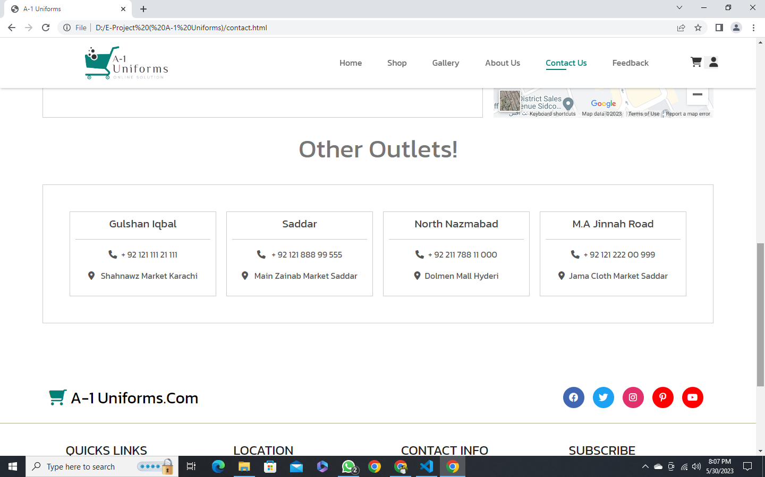

Feedback:



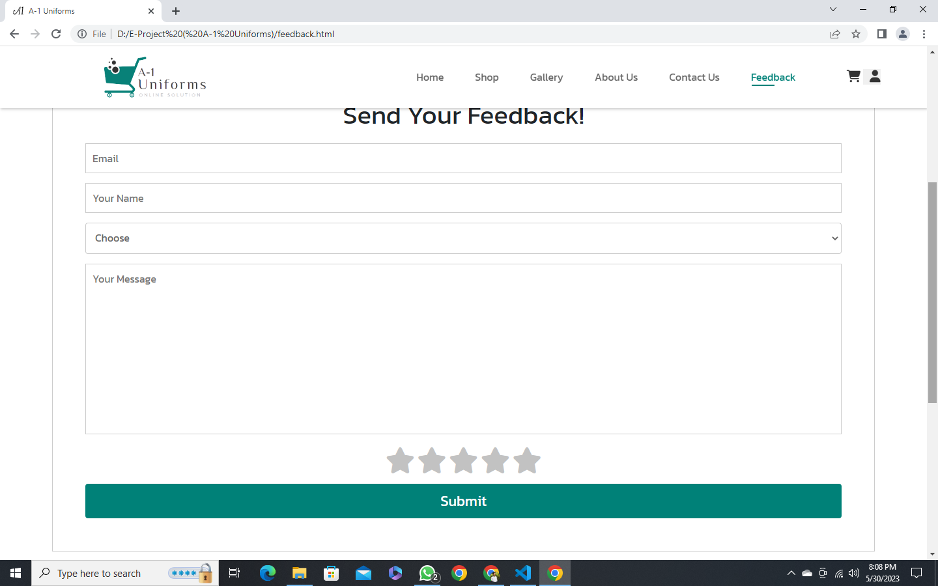

Single products details:

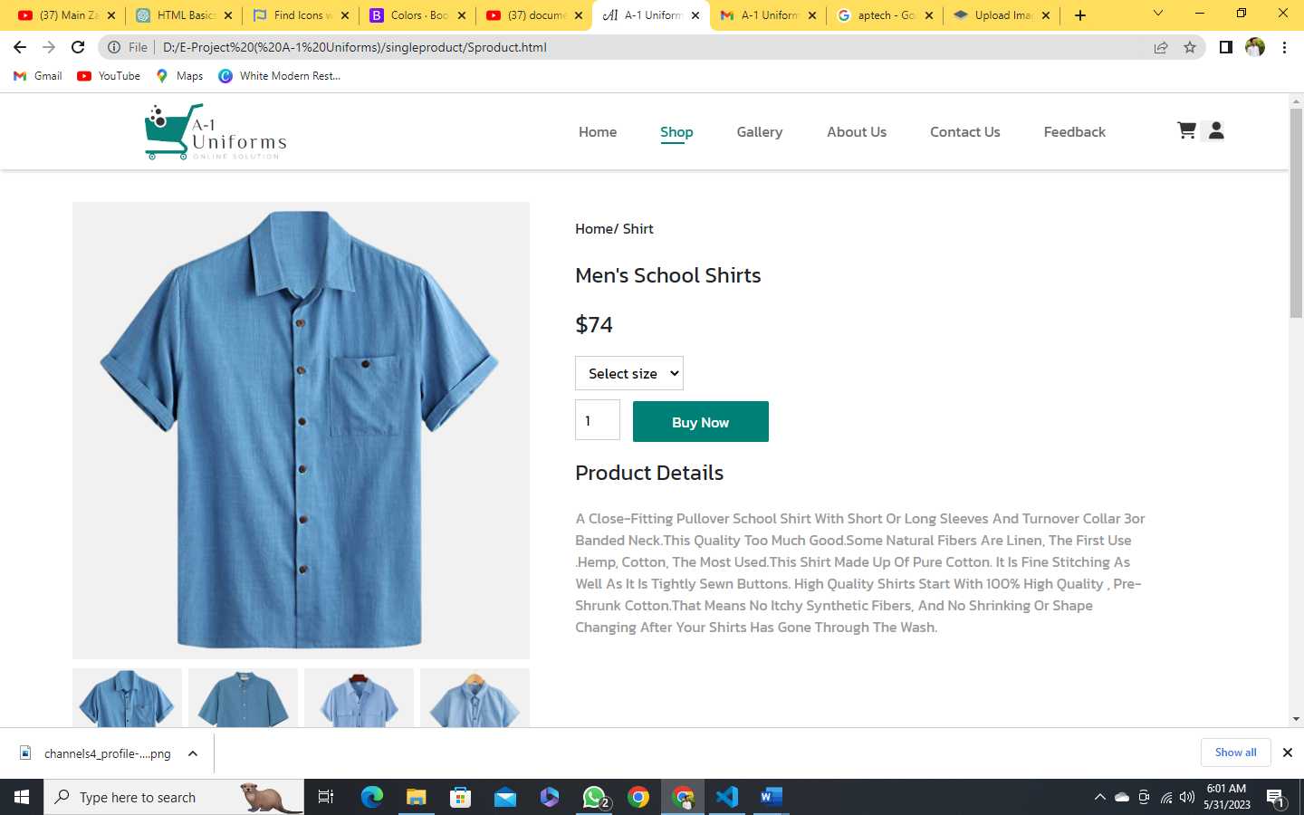

Buy now:

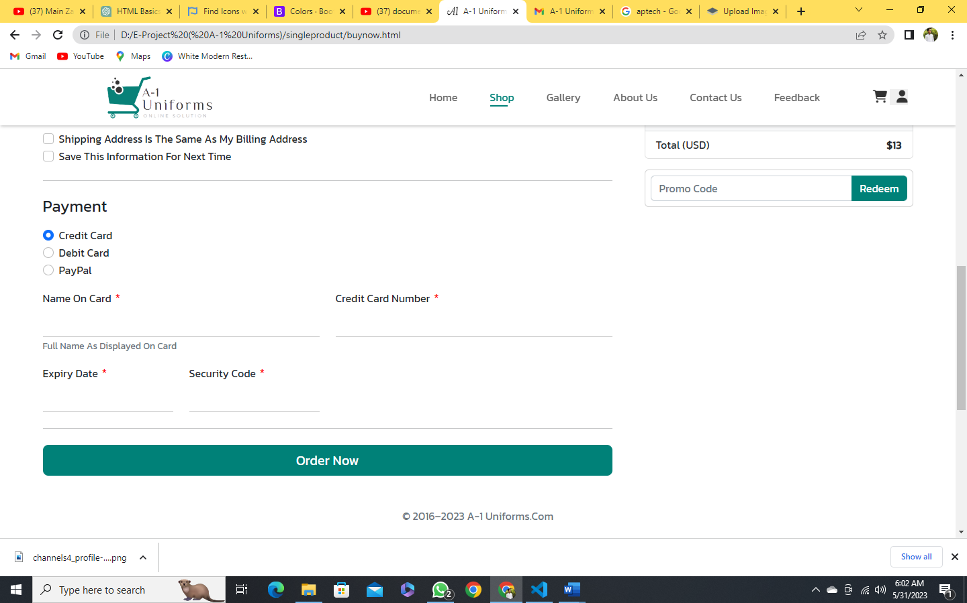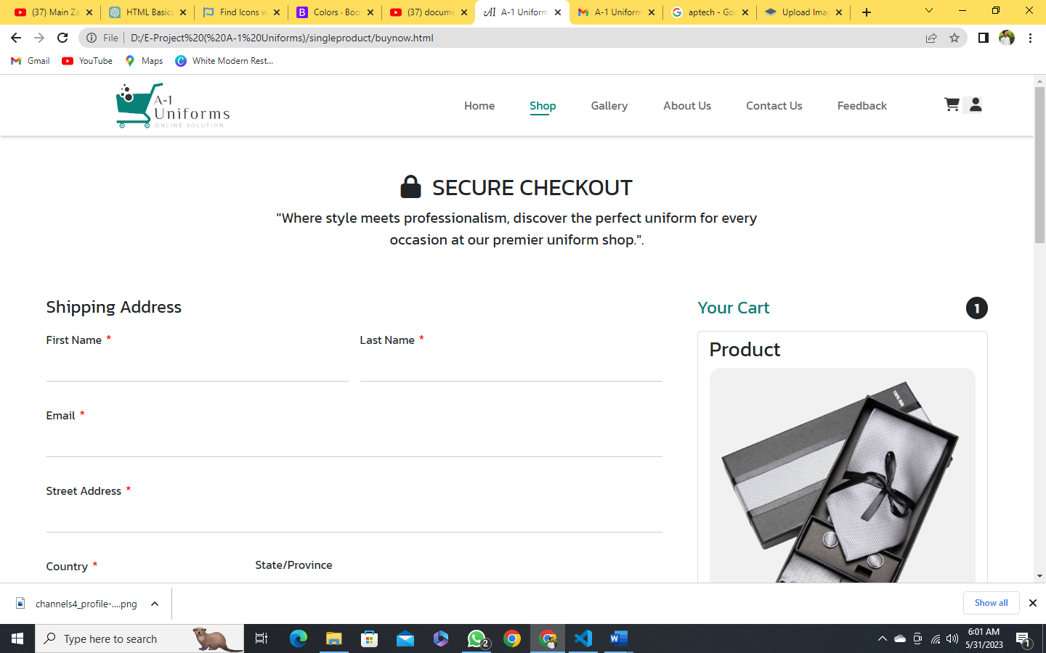

Footer:

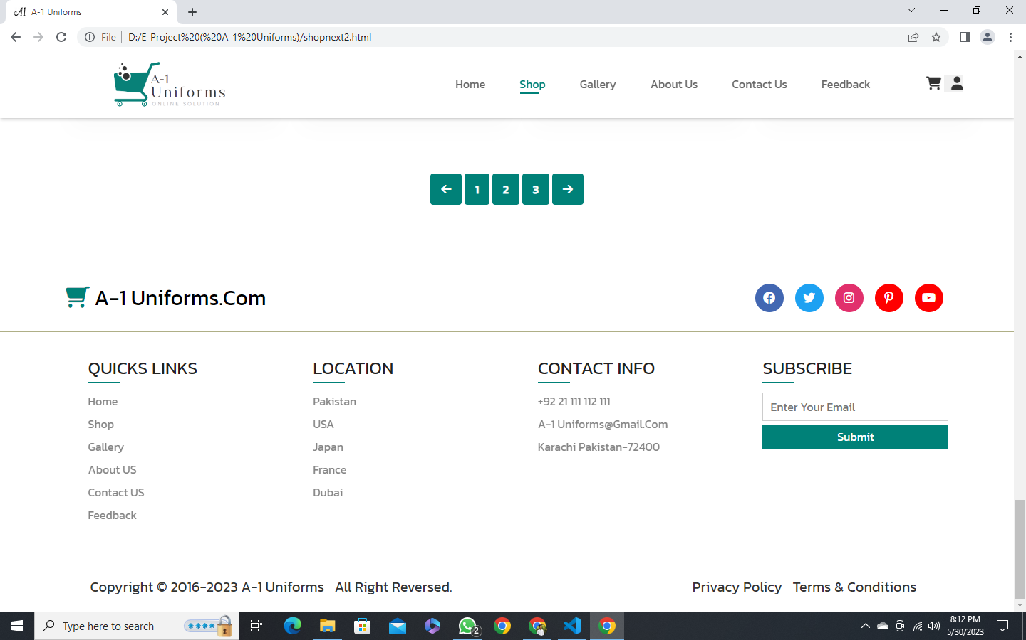

Abdul Majeed, M Usman, Hadiya Nazim, Zaid Malik

Abdul Majeed, M Usman, Hadiya Nazim, Zaid Malik

Abdul Majeed, M Usman, Hadiya Nazim, Zaid Malik

Abdul Majeed, M Usman, Hadiya Nazim, Zaid Malik

Abdul Majeed, M Usman, Hadiya Nazim, Zaid Malik

4 DAYS

10 DAYS

5 DAYS

5 DAYS

TESTING

IMPLEMENTATION

DESIGNING

PLAINING

6 DAYS

ANALYSIS

|  |  |  |
| --- | --- | --- |
| **PHASES** | **TIMES IN DAYS** | **TEAM MEMBER** |
|  |  |  |
|  |  |  |
|  |  |  |
|  |  |  |
|  |  |  |

**WORK BREAK DOWN**

A-1 Uniforms is a company that specializes in providing uniforms for various industries and organizations. They offer a wide range of uniform options, including clothing for healthcare professionals, public safety personnel, hospitality workers, and corporate employees.

The company focuses on delivering high-quality uniforms that are durable, comfortable, and meet the specific needs of their customers. They understand the importance of a professional appearance and aim to help businesses and organizations create a unified and cohesive image through their uniform solutions.

A-1 Uniforms takes pride in offering a diverse selection of styles, colors, and sizes to cater to different preferences and body types. They also provide customization options such as adding company logos or embroidery to the uniforms, allowing businesses to personalize their apparel.

In addition to uniforms, A-1 Uniforms may offer related products like accessories, shoes, and workwear to complete the ensemble. They strive to ensure customer satisfaction by providing excellent customer service, quick order processing, and competitive pricing.

Overall, A-1 Uniforms is a reliable provider of high-quality uniforms, catering to various industries and offering customization options to meet the specific needs of their customers.

**CONCLUSION**